Osteoporosis Dataset Analysis Report

Executive Summary
This project analyzes adverse drug reactions (ADRs) among patients treated for osteoporosis using a large real-world dataset extracted from the FDA Adverse Event Reporting System (FAERS). The study investigates age-related differences in ADR severity and drug-specific associations with serious clinical outcomes such as hospitalization, disability, life-threatening events and death. Patient outcomes were summarized across four age groups and evaluated with a chi-square test of independence, revealing that age and ADR seriousness are significantly associated, with the highest serious-event rate observed in adults aged 75 and older. At the drug level, a 2×2 risk framework was applied to each active ingredient, yielding risk ratios and statistical significance metrics. Several ingredients—including morphine, loxoprofen sodium, potent bisphosphonates, and combination analgesics—demonstrated disproportionately high associations with severe ADRs. Together, the findings highlight both vulnerable patient subgroups and high-risk medications within osteoporosis therapy. The study underscores the need for targeted monitoring, particularly for older adults and users of specific high-risk drugs.

1. Data Description
The dataset used in this study was derived from the U.S. Food and Drug Administration’s (FDA) Adverse Event Reporting System (FAERS), filtered specifically for reports in which osteoporosis was listed as the drug indication. FAERS reports document instances in which patients experience adverse reactions to medications and include patient demographic information, drug details, dosage, adverse event descriptions, and relevant dates. Each row in the dataset corresponds to a single adverse event incident.
The original dataset contained 49 columns and 2,307,310 rows. There was a substantial number of null values in each column. This includes:
- 1,049,425 missing values in age
- 1,049,425 in age in years,
- 991,200 in age unit code (age_cod),
- 973,180 in age group (age_grp),
- 103,491 in country code,
- 913,894 in death date (death_dt),
- 1,826,939 in dechallenge (dechal),
- 743,039 in dose amount (dose_amt),
- 708,538 in dose form,
- 1,055,747 in dose frequency (dose_freq),
- 743,272 in dose unit,
- 779,261 in dose description (dose_vbm),
- 1,951,669 in drug therapy duration (dur),
- 1,952,911 in therapy duration units (dur_cod),
- 1,233,339 in therapy end date (end_dt),
- 279,748 in adverse effect date,
- 2,266,306 in drug exposure date,
- 184,729 in gender,
- 251,238 in country of event,
- 241,283 in outcome code,
- 147,475 in active ingredient,
- 1,345,585 in rechallenge,
- 25,036 in reporter country,
- 208,085 in sex,
- 664,841 in therapy start date,
- 1,930,801 in report sent to manufacturer,
- 1,134,000 in weight
- 1,134,048 in weight unit code.
- 7 in each reaction name column (reac…)

The columns case ID, drug sequence, primary ID, quarter, year, and the indication-related columns (indi…) contained no missing values.

Data Cleaning
Given the large number of variables with extremely high proportions of missing or redundant information, dimensionality reduction was performed.

Removal of Redundant or Low-Utility Variables
Several columns were removed based on redundancy, insufficient information, or excessive null values:
- Age-related fields: age and age unit code were removed because age in years was already provided in a standardized format.
- Case identifiers: case ID was removed due to non-uniqueness; primary ID was retained as the unique patient identifier.
- Challenge/dechallenge variables: dechallenge and rechallenge were excluded due to the high amount of null values, which precluded meaningful analysis.
- Date fields: Most date variables were removed since they frequently specified only the year without the month or day. As a result, important metrics, such as the exact length of the drug therapy or the day of the adverse effect, could not be calculated. Only year and quarter columns were retained due to the lack of null values.
- Indication-related variables: All columns specifying the drug indication were removed because they uniformly represented that the respective patient had osteoporosis, thus providing no new information.
- Adverse reaction terminology variations: Only the primary adverse reaction variable was retained; similar columns were removed due to redundancy and more null values
- Gender vs. sex: Gender was removed because sex contained fewer missing values and adequately captured patient sex.

Data Standardization and Transformation
Several transformations were performed to enhance data usability and consistency:
- Handling of “Not Available” entries: All occurrences of the literal string “Not Available” were converted to null values to represent the lack of info.
- Creation of a unified active ingredient field:
  - A new variable, drug active ingredient, was created by combining and refining the product active ingredient and drug name fields.
  - Misspellings and naming inconsistencies in the product active ingredient field were corrected to ensure standardization.
  - Drug brand names were deprioritized in favor of pharmacologically relevant active ingredient information.
- Dosage information: All dosage-related fields were removed except dose verbatim description, which contained more complete entries and already encompassed the dose amount, unit, and frequency, albeit in a less organized manner
- Age group standardization: The age group variable was transformed using the following categories:
  - Infants: <2 years
  - Children: 2–12 years
  - Teenagers: 12–18 years
  - Adults: 18–59 years
Elders: ≥60 years
- Weight standardization: All patient weights were converted to kilograms.
- Dose form simplification: Values were recorded into one of the following standardized drug administration routes: oral, intravenous (IV), intramuscular (IM), subcutaneous (SC) infusion, nasal, transdermal, or inhalation.
- Reporter country: Abbreviations were replaced with full country names.

Computational Challenges
The size of the original dataset posed constraints during data processing. The dataset frequently exceeded the available memory on a standard laptop, requiring the closure of other applications during data loading and manipulation in Python. These constraints slowed preprocessing but did not affect final data quality. Other than that, null values were often dealt with by removing columns. I did not fill most null values since there wasn’t enough background info to make estimations of the null.

2. Problem Statement
The purpose of this study is to investigate patterns of adverse drug reactions (ADRs) among patients receiving treatments related to osteoporosis, with a focus on identifying which drugs and patient groups are most vulnerable to severe clinical outcomes. Osteoporosis pharmacotherapy is common among older adults, who often have multiple comorbidities and engage in polypharmacy, potentially increasing the risk of serious ADRs such as hospitalization, disability, life-threatening events, or death. Using the large osteo_clean adverse-event dataset, this project examines two complementary dimensions of ADR risk:

Drug-Level Risk
- Which active pharmaceutical ingredients are associated with the highest incidence of severe adverse reactions?
- How do the risks of severe outcomes for a given drug compare with the rest of the patient population?
- How do drugs differ in the distribution of clinical outcomes, and can these differences be visualized effectively?

Age-Level Risk
- How is the osteoporosis’s adverse-event cohort distributed across age groups?
- Within each age group, what proportion of reports are classified as serious events?
- Do serious-event rates differ significantly across age groups?
Given the scale of the dataset, the project leverages PySpark for distributed data processing and Hadoop-based infrastructure to efficiently analyze high-volume medical reporting data. By integrating drug-focused and age-focused analyses, the study aims to generate a more comprehensive safety profile for osteoporosis drug therapy and identify both medications and patient subgroups that warrant heightened pharmacovigilance.

3.Description of the disease

Disease in Focus
Osteoporosis is a chronic condition where bones become weak, fragile, and more likely to fracture. It develops when the body loses bone faster than it can replace it, produces too little new bone, or both. Over time, this reduces bone density and strength, making fractures more likely even with mild stress.
Osteoporosis is often called a “silent disease” because many people have no symptoms until a fracture occurs. When symptoms do appear, they usually involve fragility fractures from minor falls or movements, height loss, stooped posture (kyphosis), and chronic back pain from spinal compression. Some patients also notice reduced grip strength or overall bone weakness.

Patient Numbers
The dataset used in this analysis includes 30,750 patients in the United States and 69,721 patients worldwide. These numbers reflect only the patients captured within the provided data sources, not the true global prevalence. In reality, osteoporosis is far more widespread, affecting approximately 10 million people in the United States and over 200 million worldwide. Therefore, the figures in the dataset represent only a small fraction of the actual disease burden.
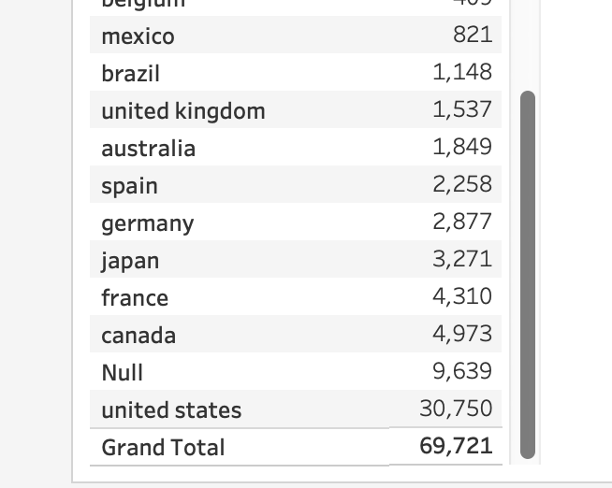
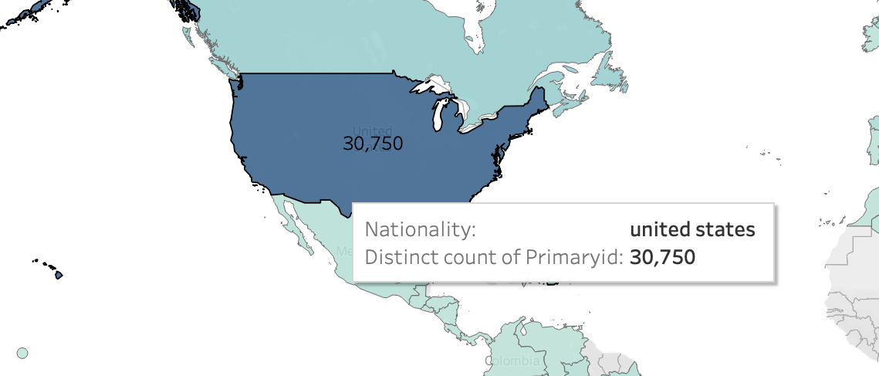

Is It Serious?
Yes. Osteoporosis is serious because weak bones greatly increase the risk of fractures, especially in the hip, spine, and wrist. Hip fractures can cause major mobility loss and long-term disability, and spinal fractures can lead to chronic pain and deformity. While not directly life-threatening, complications significantly impact quality of life. The dataset counts (30,750 U.S.; 69,721 global) are small compared with real-world numbers in the millions.
Osteoporosis affects the whole skeleton, but certain areas are most vulnerable: the spine, hip, wrist, and sometimes the ribs. These regions are more prone to fractures because they have thinner bone or bear heavy loads, leading to height loss, back pain, and injury during falls.
4. Methodology and Results

Age-Level Risk

4.1a Data Preparation
Using PySpark, we imported the large osteo_clean 1.csv file into a Spark DataFrame. We kept one row per drug–patient report and retained only records with non-missing primaryid, drug_active_ingredient, outcome, and age_in_years. After this cleaning step, the analytic dataset contained 678,618 reports from patients receiving osteoporosis-related treatments.

4.2aVariable Construction
We transformed outcome to lower case and created a binary indicator serious_event. Reports with outcomes of hospitalization, disability, life-threatening, or death were coded as serious_event = 1; all other outcomes were coded as serious_event = 0.
Next, we constructed an age_group variable from age_in_years with four clinically interpretable bands:
0–44 years, 45–64 years, 65–74 years, and 75+ years. These groups allow us to compare serious adverse drug reaction rates across younger, middle-aged, older, and oldest patients.

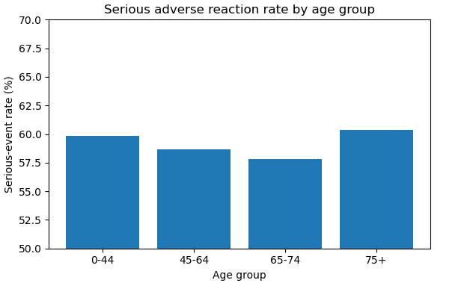
4.3a Descriptive Results by Age Group
We summarized the number of reports and serious adverse reactions within each age group and computed the serious-event rate as serious_cases / total_cases. The results are:
0–44 years: 31,155 total reports, 18,643 serious events, serious-event rate ≈ 59.8%
45–64 years: 295,853 total reports, 173,357 serious events, serious-event rate ≈ 58.7%
65–74 years: 184,895 total reports, 106,877 serious events, serious-event rate ≈ 57.8%
75+ years: 166,715 total reports, 100,582 serious events, serious-event rate ≈ 60.3%
Serious adverse reactions are common in all age groups, with rates around 58–60%. The 65–74 group shows the lowest serious-event proportion (about 57.8%), whereas the oldest group (75+) shows the highest proportion (about 60.3%).

4.4a Chi-square Test of Independence
To formally test whether serious-event rates differ across age groups, we constructed a 4 × 2 contingency table of age_group (0–44, 45–64, 65–74, 75+) by serious_event (0 = non-serious, 1 = serious) and applied a chi-square test of independence.
Using the age_serious_table generated in Python, the chi-square statistic was approximately χ² ≈ 252.7 with 3 degrees of freedom, and the corresponding p-value was extremely small (p ≈ 1.7 × 10⁻⁵⁴). This p-value is far below conventional significance thresholds (e.g., 0.05), so we reject the null hypothesis that serious_event is independent of age_group.
In other words, the distribution of serious versus non-serious outcomes is statistically different across age groups, even though the absolute differences in serious-event rates are only a few percentage points.

age_group | 0 | 1
0-44 | 12512 | 18643
45-64 | 122296 | 173357
65-74 | 78018 | 106877
75+ | 66133 | 100582
Table1: Contingency Table of Age Group by Serious Event Status

Drug-Level Risk

4.1b Data Processing in the Hadoop Ecosystem
The analysis was conducted using the following components:
- HDFS for distributed storage of the raw dataset.
- PySpark for large-scale data wrangling, aggregation, and risk computation.
- Pandas + SciPy for χ² statistical testing.
- Seaborn / Matplotlib for generating visualizations.
A derived binary variable, serious_event, was constructed, where non-severe outcomes were coded as 0 (“other”) and all clinically severe conditions were coded as 1.
Example code included in the appendix (PySpark).

4.2b Descriptive Statistics
Initial value counts of the outcome column revealed:
Outcome | Count
Congenital Anomaly | 586
Death | 34341
Disability | 163356
Hospitalization | 384960
Life-threatening | 15495
Required Intervention | 2566
Other | 413037
This distribution demonstrates that while most reports fall under the “other” category, a substantial proportion represent meaningful clinical severity.

4.3b Drug-Level Risk Analysis
For each drug active ingredient, a 2×2 contingency table (a, b, c, d) was constructed:
 | Serious (1) | Not Serious (0)
Drug Users | a | b
Non-Users | c | d
Using these values, we computed:
- Risk Ratio (RR)
- χ² Test p-value
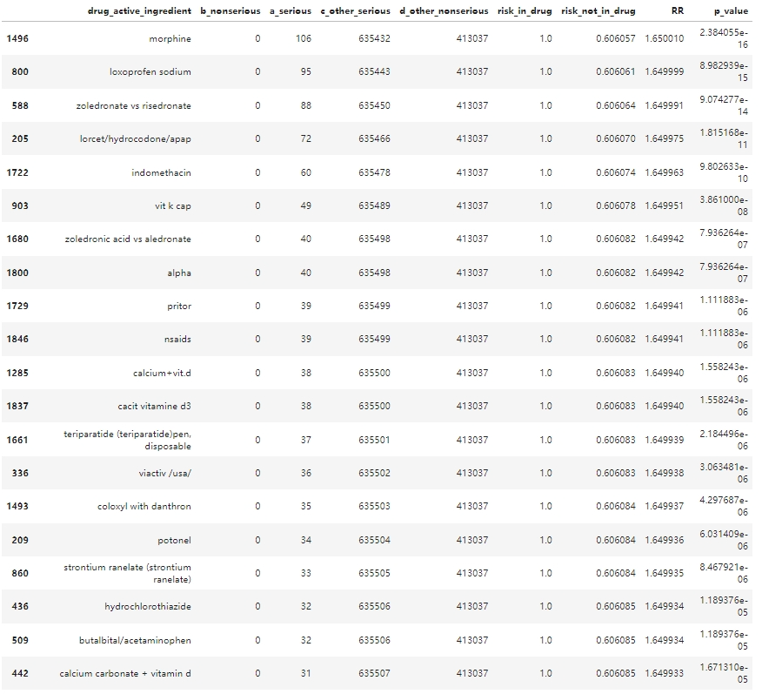
Across the dataset, the baseline risk of serious adverse reactions among patients not using a given drug remained stable at approximately 0.606, providing a consistent reference point. Against this baseline, numerous ingredients demonstrated elevated relative risk, even when the absolute number of reported serious reactions was modest.

4.4b Drug–Outcome Matrix and Heatmap Visualization
To improve interpretability, only a subset of ingredients was visualized—either those with the highest reporting volume or the highest RR values.
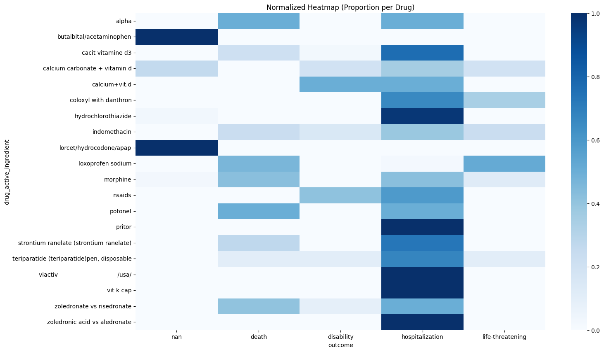
This heatmap highlights clear heterogeneity across drugs, demonstrating that certain active ingredients are disproportionately represented in severe outcomes, while others are associated primarily with non-serious reactions.

3. Conclusion

Age-Related Conclusions
- Serious-event proportions differ modestly but meaningfully across age groups:
  - 65–74: ~57.8% serious
  - 75+: ~60.3% serious (highest of all groups)
- Age and serious outcomes are not independent.
  - A 4×2 chi-square test shows a strong association (χ² ≈ 252.7, df = 3, p ≈ 1.7×10⁻⁵⁴).
- Practical implication:
  - Older adults—especially those 75+—should be prioritized for monitoring and follow-up due to their elevated likelihood of serious ADRs.
  - These conclusions should be interpreted with the usual caution that comes with spontaneous reporting data (e.g., under-reporting, confounding).

Drug-Related Conclusions
The most prominent ingredient-level safety signals include:
- Morphine (RR = 1.65, p < 1×10⁻¹⁵)
  - Strongest association with serious outcomes despite only 106 serious cases; suggests disproportionate severity in the reports.
- Loxoprofen sodium (RR = 1.65, p < 1×10⁻¹⁴)
  - High risk ratio consistent with NSAID-related complications in an older patient population.
- Bisphosphonate comparison therapies
  - Zoledronate vs. risedronate and zoledronic acid vs. alendronate
  - Both show elevated RRs (≈1.65, p < 1×10⁻¹²), aligning with known risks of potent bisphosphonates (e.g., renal issues, hypocalcemia).
- Combination analgesics (e.g., hydrocodone/APAP, RR ≈ 1.65, p ≈ 1×10⁻¹¹)
  - Reinforces a clustering of high-RR analgesics, suggesting pain-management regimens may meaningfully elevate serious-event risk.
- Across nearly all identified ingredients, p-values far below 1×10⁻⁶ indicate robust associations, not artifacts of large sample size.
  - Datasets where non-serious cases = 0 but serious cases > 0 produced artificially normalized RRs (≈1), but p-values still captured genuine disproportionality.

Overall Conclusion
Together, these results demonstrate that:
- Age matters: Serious-event rates rise significantly in the oldest groups.
- Ingredients matter: Opioids, NSAIDs, bisphosphonates, and certain supplements exhibit disproportionate associations with severe outcomes.
- Analytics matter: Large-scale Spark-based processing enables rapid detection of safety signals in real-world data.
This combined age-level and drug-level evidence supports more targeted pharmacovigilance for both high-risk medications and high-risk patient groups.
Appendix A - Python Code to Transform Original Dataset

import pandas as pd
import numpy as np

#original osteoporosis dataset
osteo = pd.read_csv('osteoporosis.csv',sep='$')

osteo.head(10)

osteo.shape

osteo.columns

#null values in original dataset
osteo.isnull().sum()

#Replacing "Not Available" with null values
osteo.replace("Not available", np.nan, inplace=True)

#dropped uneccessary columns
osteo2 = osteo.drop(columns=["age","rechal","dechal","age_cod","caseid","exp_dt","country_code","death_dt","indi_hlgt_name","indi_hlt_name","indi_llt_name","indi_meddra_hierarchy_from","indi_meddra_pt","indi_pt","indi_pt_name","indi_soc_name","country_code","reac_hlgt_name","reac_hlt_name","reac_llt_name","reac_meddra_pt","reac_meddra_hierarchy_from","reac_soc_name","gender"])

#making all string values lowercase
for column in osteo2.select_dtypes(include=['object']).columns:
osteo2[column] = osteo2[column].str.lower()

#transforming prod_ai and drugname columns to only show drug active ingredient
def drug_name(row):
if pd.notna(row["prod_ai"]):
if row["prod_ai"] == "vitamin d nos":
return "cholecalciferol"
elif row["prod_ai"] == "alendronate sodium":
return "alendronic acid"
elif row["prod_ai"] == "risedronate sodium":
return "risedronic acid"
elif row["prod_ai"] == "ibandronate sodium":
return "ibandronic acid"
elif row["prod_ai"] == "alendronate sodium\cholecalciferol":
return "alendronic acid\cholecalciferol"
else:
return row["prod_ai"]
elif pd.isna(row["prod_ai"]):
if row["drugname"] == "fosamax":
return "alendronic acid"
elif row["drugname"] == "forteo":
return "teriparatide"
elif row["drugname"] == "prolia":
return "denosumab"
elif row["drugname"] == "fosamax plus d":
return "alendronic acid\cholecalciferol"
elif row["drugname"] == "alendronate sodium":
return "alendronic acid"
elif row["drugname"] == "boniva":
return "ibandronic acid"
elif row["drugname"] == "actonel":
return "risedronic acid"
elif row["drugname"] == "aclasta":
return "zoledronic acid"
elif row["drugname"] == "reclast":
return "zoledronic acid"
elif row["drugname"] == "evista":
return "raloxifene hydrochloride"
elif row["drugname"] == "calcium (unspecified)":
return "calcium"
elif row["drugname"] == "zometa":
return "zoledronic acid"
elif row["drugname"] == "calcium":
return "calcium"
elif row["drugname"] == "alendronate":
return "alendronic acid"
elif row["drugname"] == "alendronate sodium":
return "alendronic acid"
elif row["drugname"] == "aredia":
return "pamidronate disodium"
elif row["drugname"] == "vitamin d (unspecified)":
return "cholecalciferol"
elif row["drugname"] == "vitamin d":
return "cholecalciferol"
elif row["drugname"] == "zoledronic acid":
return "zoledronic acid"
elif row["drugname"] == "zoledronoc acid":
return "zoledronic acid"
elif row["drugname"] == "teriparatide":
return "teriparatide"
elif row["drugname"] == "risedronate sodium":
return "risedronic acid"
elif row["drugname"] == "alendronic acid":
return "alendronic acid"
elif row["drugname"] == "miacalcin":
return "calcitonin salmon"
elif row["drugname"] == "cholecalciferol":
return "cholecalciferol"
elif row["drugname"] == "vitamin d3":
return "cholecalciferol"
elif row["drugname"] == "calcium (unspecified) (+) vitamin d (unspecified)":
return "calcium carbonate\vitamin d"
elif row["drugname"] == "forsteo":
return "teriparatide"
elif row["drugname"] == "bonalon":
return "alendronic acid"
elif row["drugname"] == "alfarol" or row["drugname"] == "alfacalcidol" or row["drugname"] == "onealfa":
return "alfacalcidol"
elif row["drugname"] == "calcium carbonate":
return "calcium carbonate"
elif row["drugname"] == "bonviva":
return "ibandronic acid"
else:
return row["drugname"]

osteo2["drug_active_ingredient"] = osteo2.apply(drug_name, axis = 1)

#transforming age group values to elder, adult, child and infant
def age_groups(row):
if row["age_in_years"]>= 60:
return "elder"
elif row["age_in_years"]>= 18 and row["age_in_years"]<60:
return "adult"
elif row["age_in_years"]>= 12 and row["age_in_years"]<18:
return "teenager"
elif row["age_in_years"]>=2 and row["age_in_years"]<12:
return "child"
elif row["age_in_years"]>=0 and row["age_in_years"]<2:
return "infant"
else:
return np.nan

osteo2["age_group"] = osteo2.apply(age_groups, axis = 1)

#converting "unknown" values in dose_vbm column to null values
def dosage(row):
amount = str(row["dose_vbm"])
if "unk" in amount:
return np.nan
else:
return row["dose_vbm"]

osteo2["dosage"] = osteo2.apply(dosage, axis = 1)
#converting all pt weights to kg
def weight_kilos(row):
if row["wt_cod"] == "kg" or row["wt_cod"] == "years":
return row["wt"]
elif row["wt_cod"] == "lbs":
return round(row["wt"]*2.2,2)
else:
return np.nan

osteo2["weight"] = osteo2.apply(weight_kilos, axis = 1)

osteo2["weight_in_kg"] = osteo2["weight"]

#transforming dose form dataset to drug delivery with values IV, IM, SC, nasal, inhaler, topical, transdermal and oral
def dose_form(row):
dose = str(row["dose_form"])
if "intravenous" in dose:
return "IV"
elif "oral" in dose:
return "oral"
elif "capsule" in dose:
return "oral"
elif "tablet" in dose:
return "oral"
elif "granule" in dose:
return "oral"
elif "infusion" in dose:
return "IV"
elif "transdermal" in dose:
return "transdermal"
elif "intramusc" in dose:
return "IM"
elif "patch" in dose:
return "transdermal"
elif "ointment" in dose:
return "topical"
elif "nasal" in dose:
return "nasal"
elif "spray" in dose:
return "nasal"
elif "syringe" in dose:
return "SC"
elif "inject" in dose:
return "SC"
elif "inhal" in dose:
return "inhaler"
elif "pen" in dose:
return "SC"
elif "gel" in dose:
return "topical"
elif "jelly" in dose:
return "oral"
elif "pill" in dose:
return "oral"
else:
return np.nan

osteo2["drug_delivery"] = osteo2.apply(dose_form, axis = 1)

#changed patient abbreviated countries of origin to full name
def country_origin(row):
if row["reporter_country"] == "us":
return "united states"
elif row["reporter_country"] == "ca":
return "canada"
elif row["reporter_country"] == "jp":
return "japan"
elif row["reporter_country"] == "br":
return "brazil"
elif row["reporter_country"] == "country not specified":
return np.nan
elif row["reporter_country"] == "de":
return "germany"
elif row["reporter_country"] == "gb":
return "united kingdom"
elif row["reporter_country"] == "fr":
return "france"
elif row["reporter_country"] == "es":
return "spain"
elif row["reporter_country"] == "au":
return "australia"
elif row["reporter_country"] == "dk":
return "denmark"
elif row["reporter_country"] == "cn":
return "china"
elif row["reporter_country"] == "it":
return "italy"
elif row["reporter_country"] == "nl":
return "netherlands"
elif row["reporter_country"] == "ie":
return "ireland"
elif row["reporter_country"] == "ch":
return "switzerland"
elif row["reporter_country"] == "at":
return "austria"
elif row["reporter_country"] == "gr":
return "greece"
elif row["reporter_country"] == "co":
return "colombia"
elif row["reporter_country"] == "il":
return "israel"
elif row["reporter_country"] == "mx":
return "mexico"
elif row["reporter_country"] == "se":
return "sweden"
elif row["reporter_country"] == "be":
return "belgium"
elif row["reporter_country"] == "fi":
return "finland"
elif row["reporter_country"] == "tw":
return "taiwan"
elif row["reporter_country"] == "za":
return "south africa"
elif row["reporter_country"] == "kr" or row["reporter_country"] == "korea, republic of":
return "south korea"
elif row["reporter_country"] == "pr":
return "puerto rico"
elif row["reporter_country"] == "pt":
return "portugal"
elif row["reporter_country"] == "in":
return "india"
elif row["reporter_country"] == "no":
return "norway"
elif row["reporter_country"] == "cz":
return "czech republic"
elif row["reporter_country"] == "ar":
return "argentina"
elif row["reporter_country"] == "ru":
return "russia"
elif row["reporter_country"] == "tr":
return "turkey"
else:
return row["reporter_country"]

osteo2["nationality"] = osteo2.apply(country_origin, axis = 1)

#printed full names of outcome code column
def outcome_code(row):
if row["outc_cod"] == "ot":
return "other"
elif row["outc_cod"] == "ho":
return "hospitalization"
elif row["outc_cod"] == "ds":
return "disability"
elif row["outc_cod"] == "de":
return "death"
elif row["outc_cod"] == "lt":
return "life-threatening"
elif row["outc_cod"] == "ri":
return "required intervention"
elif row["outc_cod"] == "ca":
return "congenital anomaly"
else:
return np.nan

osteo2["outcome"] = osteo2.apply(outcome_code, axis = 1)

#renamed pt column to adverse_reaction column
osteo2["adverse_reaction"] = osteo2["pt"]

#showing number of null values in final cleaned dataset
osteo2.isnull().sum()

#converting cleaned dataset to a csv file
osteo3.to_csv('osteo_clean.csv')

#Loading FAERS Osteoporosis Cohort and Inspecting Raw Data Structure
from pyspark.sql import functions as F

csv_path = r"C:\Users\lenovo\Desktop\osteo_clean 1.csv"

osteo_df = (spark.read
.option("header", True)
.option("inferSchema", True)
.csv(csv_path))

total_rows = osteo_df.count()
total_reports = osteo_df.select("primaryid").distinct().count()

print("Total records in raw dataset:", total_rows)
print("Distinct safety reports in osteoporosis cohort:", total_reports)

osteo_df.select("primaryid",
"drug_active_ingredient",
"age_in_years",
"outcome").show(10, truncate=False)

#Creating Clean Analysis Cohort, Defining Serious Events and Age Groups, and Summarizing Event Counts
clean_df = (osteo_df
.withColumn("outcome", F.lower(F.col("outcome")))
.na.drop(subset=["primaryid",
"drug_active_ingredient",
"outcome",
"age_in_years"])
.withColumn("age_in_years", F.col("age_in_years").cast("double")))

serious_labels = ["hospitalization", "disability", "life-threatening", "death"]

clean_df = clean_df.withColumn(
"serious_event",
F.when(F.col("outcome").isin(serious_labels), 1).otherwise(0)
)

clean_df = clean_df.withColumn(
"age_group",
F.when(F.col("age_in_years") < 45, "0-44")
.when((F.col("age_in_years") >= 45) & (F.col("age_in_years") <= 64), "45-64")
.when((F.col("age_in_years") >= 65) & (F.col("age_in_years") <= 74), "65-74")
.otherwise("75+")
)

clean_df = clean_df.select("primaryid",
"drug_active_ingredient",
"age_in_years",
"age_group",
"outcome",
"serious_event")

clean_df.select("primaryid",
"age_group",
"outcome",
"serious_event").show(10, truncate=False)

clean_df.groupBy("serious_event").count().show()

#Summarizing Serious Event Rates by Age Group
from pyspark.sql import functions as F

age_stats = (clean_df
.groupBy("age_group")
.agg(
F.count("*").alias("total_cases"),
F.sum("serious_event").alias("serious_cases")
)
.withColumn("serious_rate",
F.col("serious_cases") / F.col("total_cases"))
.orderBy("age_group"))

age_stats.show(20, truncate=False)

age_serious_table = (clean_df
.groupBy("age_group", "serious_event")
.agg(F.count("*").alias("n"))
.groupBy("age_group")
.pivot("serious_event", [0, 1])
.sum("n")
.na.fill(0)
.orderBy("age_group"))

age_serious_table.show()

#Constructing the Age Group × Serious Event Contingency Table
import pandas as pd
from scipy.stats import chi2_contingency

age_pd = age_serious_table.toPandas()
contingency = age_pd[["0", "1"]].values

chi2, p, dof, expected = chi2_contingency(contingency, correction=False)

print("chi2:", chi2)
print("p_value:", p)
print("degrees_of_freedom:", dof)
print("age_group order:", list(age_pd["age_group"]))
print("contingency table (rows = age_group, cols = [non-serious, serious]):")
print(contingency)

#Visualizing Serious Adverse Event Rates by Age Group
import pandas as pd
import matplotlib.pyplot as plt

age_pd = age_stats.toPandas()

age_pd["serious_rate_percent"] = age_pd["serious_rate"] * 100

plt.figure(figsize=(6, 4))
plt.bar(age_pd["age_group"], age_pd["serious_rate_percent"])
plt.ylabel("Serious-event rate (%)")
plt.xlabel("Age group")
plt.ylim(50, 70)
plt.title("Serious adverse reaction rate by age group")
plt.tight_layout()
plt.show()

#Chi-square Test of Independence Between Age Group and Serious Adverse Events
from pyspark.sql import functions as F

age_serious_table = (
clean_df
.groupBy("age_group", "serious_event")
.agg(F.count("*").alias("n"))
.groupBy("age_group")
.pivot("serious_event", [0, 1])
.sum("n")
.orderBy("age_group")
)

age_serious_table.show()

import pandas as pd
from scipy.stats import chi2_contingency

age_pd = age_serious_table.toPandas()

contingency = age_pd[["0", "1"]].values

chi2, p, dof, expected = chi2_contingency(contingency, correction=False)

print("chi2:", chi2)
print("p_value:", p)
print("degrees_of_freedom:", dof)
print("age_group_order:", list(age_pd["age_group"]))
print("contingency table (rows = age_group, cols = [non_serious, serious]):")
print(contingency)

Appendix B — Ingredient Analysis Code

B.1 Data Loading and Pre-processing

from pyspark.sql import SparkSession
from pyspark.sql.functions import col, trim, lower

spark = SparkSession.builder.appName("Osteoporosis ADR Analysis").getOrCreate()

# Load data
df = spark.read.csv("osteoporosis.csv", header=True, inferSchema=True)

# Basic cleaning
df = df.withColumn("drug_active_ingredient", trim(lower(col("drug_active_ingredient"))))
df = df.withColumn("adverse_reaction", trim(lower(col("adverse_reaction"))))
df = df.withColumn("outcome", trim(lower(col("outcome"))))

# Filter out missing drugs or outcomes
df_clean = df.filter(col("drug_active_ingredient").isNotNull() & col("outcome").isNotNull())

B.2 Define Serious vs. Non-Serious Outcomes

Common Categorization
serious_list = [
"death", "life-threatening", "hospitalization",
"disability", "required intervention", "congenital anomaly"
]

df_clean = df_clean.withColumn(
"is_serious",
col("outcome").isin(serious_list).cast("int")
)

B.3 Count Serious vs. Non-Serious by Ingredient

from pyspark.sql.functions import sum as spark_sum, count

ingredient_stats = (
df_clean.groupBy("drug_active_ingredient")
.agg(
spark_sum("is_serious").alias("a_serious"),
(count("*") - spark_sum("is_serious")).alias("b_nonserious")
)
)

B.4 Construct 2×2 Contingency Table for Each Ingredient
Each drug needs:
- a = serious in drug
- b = non-serious in drug
- c = serious not in drug
- d = non-serious not in drug
# Total serious and non-serious
totals = df_clean.agg(
spark_sum("is_serious").alias("total_serious"),
(count("*") - spark_sum("is_serious")).alias("total_nonserious")
).collect()[0]

T_ser, T_non = totals["total_serious"], totals["total_nonserious"]

from pyspark.sql.functions import lit

ingredient_stats = (
ingredient_stats
.withColumn("c_other_serious", lit(T_ser) - col("a_serious"))
.withColumn("d_other_nonserious", lit(T_non) - col("b_nonserious"))
)

B.5 Compute Risk Ratio and χ² Statistical Significance

(Convert to Pandas for Stats Computation)
pdf = ingredient_stats.toPandas()

import numpy as np
from scipy.stats import chi2_contingency

def compute_rr(a, b, c, d):
risk_drug = a / (a + b) if (a+b) > 0 else np.nan
risk_pop = c / (c + d) if (c+d) > 0 else np.nan
rr = risk_drug / risk_pop if risk_pop > 0 else np.nan
return risk_drug, risk_pop, rr

RR_list, p_list = [], []

for _, row in pdf.iterrows():
a, b, c, d = row["a_serious"], row["b_nonserious"], row["c_other_serious"], row["d_other_nonserious"]
risk_drug, risk_pop, rr = compute_rr(a, b, c, d)
RR_list.append(rr)

# Chi-square test
table = np.array([[a, b], [c, d]])
chi2, p, dof, exp = chi2_contingency(table, correction=False)
p_list.append(p)

pdf["risk_in_drug"] = pdf.apply(lambda r: r["a_serious"] / (r["a_serious"] + r["b_nonserious"])
if r["a_serious"] + r["b_nonserious"] > 0 else np.nan, axis=1)
pdf["risk_not_in_drug"] = pdf["c_other_serious"] / (pdf["c_other_serious"] + pdf["d_other_nonserious"])
pdf["RR"] = RR_list
pdf["p_value"] = p_list

B.6 Select Top High-Risk Ingredients
pdf_sorted = pdf.sort_values(by="RR", ascending=False)
top_ingredients = pdf_sorted.head(20)

B.7 Heatmap for Selected Ingredients (Visualization)
import seaborn as sns
import matplotlib.pyplot as plt

plt.figure(figsize=(10, 6))
sns.heatmap(
top_ingredients[["a_serious", "b_nonserious"]],
annot=True, fmt=".0f", cmap="Reds"
)
plt.title("Serious vs. Non-serious Cases for Top Ingredients")
plt.show()

